**Vehicle monitoring and prediction system**

**Abstract:**

This report outlines the development of a Vehicle Monitoring and Prediction System designed to support improved traffic analysis and forecasting. The system gathers real-time vehicular data through the TomTom Traffic API. This data undergoes preprocessing and exploratory analysis using Python to identify relevant patterns and trends. The refined dataset is stored in a MySQL database to enable structured storage and efficient access. A web-based interface has been created to facilitate user interaction with the traffic data, offering dynamic visual representations. Additionally, a Power BI dashboard provides advanced visual analytics and real-time traffic prediction based on historical and live data. The system aims to aid in effective traffic management, urban planning, and timely decision-making by offering a scalable platform for monitoring vehicle flow and anticipating congestion patterns

**Introduction:**

The Vehicle Monitoring and Prediction System is a structured platform developed to collect, process, and analyze real-time traffic data. It uses API-based data sources to monitor vehicle movement, organizes the information in a structured database, and presents visual insights through interactive dashboards. The system offers the following capabilities:

1. Collection and monitoring of real-time traffic data using the TomTom API.
2. Data cleaning and analysis to identify meaningful traffic patterns.
3. Secure storage of processed data in a MySQL database.
4. A web-based interface for interactive data visualization.
5. Access to predictive traffic trends through a Power BI dashboard.

The primary goal of this system is to support urban mobility planning by enabling traffic authorities, city planners, and users to better understand traffic patterns, anticipate congestion, and respond effectively to changing traffic conditions.

**Overview of Vehicle monitoring and prediction system**

**Definition:**

The Vehicle Monitoring and Prediction System is a data-driven solution designed to monitor real-time traffic conditions and forecast congestion levels using live data from the TomTom Traffic API. The system processes and stores traffic data, applies rule-based prediction logic, and presents insights through a web interface and Power BI dashboards. It enables users to assess traffic flow based on specific locations, dates, and time periods, supporting better travel planning and traffic management.

**Objectives:**

* To collect and process real-time traffic data using the TomTom API for selected geographic locations.
* To clean and analyze the raw traffic data using Python for meaningful pattern extraction and insight generation.
* To implement a rule-based prediction system that categorizes traffic as Light, Moderate, or Heavy based on historical speed and delay metrics.
* To develop a user-friendly web interface where users can input parameters and receive traffic predictions without technical complexity.
* To store traffic data in a MySQL database for long-term use, analysis, and system scalability.
* To integrate Power BI dashboards for interactive visualization of traffic trends, congestion patterns, and historical performance.
* To support decision-making for commuters, planners, and authorities by providing reliable and accessible traffic predictions

**Components:**

• Frontend: HTML, CSS, JavaScript

• Backend: Python (Pandas)

• Database: MySQL , CSV files

• Data Visualization: Matplotlib, Seaborn

• Other Tools: Jupyter Notebook, PowerBI

**Architecture Description:**

System Components of Vehicle Monitoring and Prediction System

The system is composed of the following key components, each contributing to the seamless operation of data monitoring, processing, and prediction:

1. Data Collection (TomTom API):

The system begins with the integration of the TomTom Traffic API, which provides real-time traffic data, including congestion levels, travel times, and vehicle density across selected routes and regions.

1. Data Cleaning and EDA (Python):

Collected data is cleaned and preprocessed using Python. Exploratory Data Analysis (EDA) is conducted using libraries such as Pandas, Matplotlib, and Seaborn to uncover trends, anomalies, and traffic patterns.

1. Data Storage and Analysis (CSV & MySQL):

The system employs a hybrid data storage strategy:

CSV Files are used for initial storage and quick access:

tomtom_traffic_data.csv stores raw traffic data fetched from the TomTom API.

new_csv_data.csv contains the cleaned and preprocessed data ready for analysis or display.

MySQL Database is utilized for advanced querying, structured analysis, and long-term storage of cleaned data. This allows the system to perform more efficient data manipulation, filtering, and aggregation using SQL-based operations, supporting deeper insights and scalability.

1. Web Interface (HTML, CSS, JavaScript):

The front-end interface of the system is developed using standard web technologies—HTML for structure, CSS for styling, and JavaScript for interactivity. It allows users to load and interact with traffic data from CSV files, which represent processed outputs from the backend system. The interface offers an intuitive way to view traffic metrics, trends, and location-specific insights, making the system accessible and responsive for end users.

1. Dashboard and Prediction (Power BI with MySQL Integration):

Power BI is used to create a dynamic and interactive dashboard for visualizing traffic data and generating real-time insights. The cleaned data stored in MySQL is directly connected to Power BI, allowing seamless synchronization and live updates for dashboards. This enables:

* Interactive charts and visuals for traffic patterns, congestion levels, and temporal trends.
* Real-time monitoring capabilities using live MySQL connections.
* Predictive analytics through data modelling and trend forecasting features built into Power BI.

This component serves as the final layer of the system, providing stakeholders with intuitive and actionable insights for traffic planning and decision-making.

**Block Diagram:**

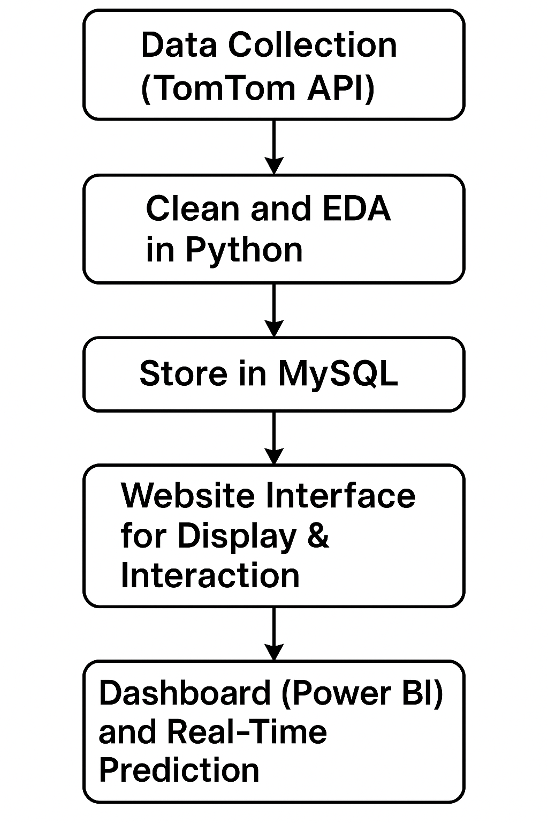

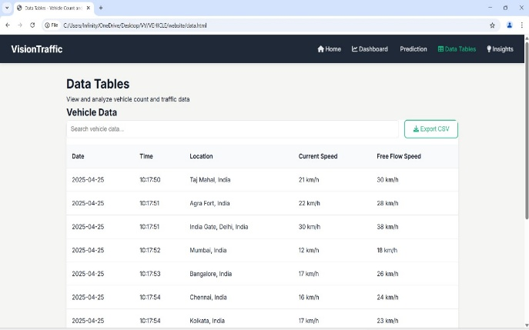 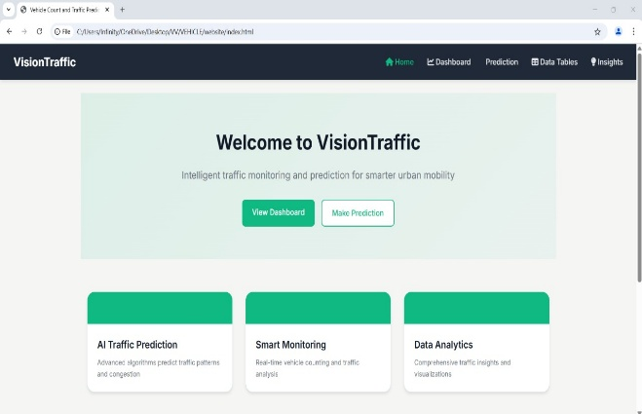

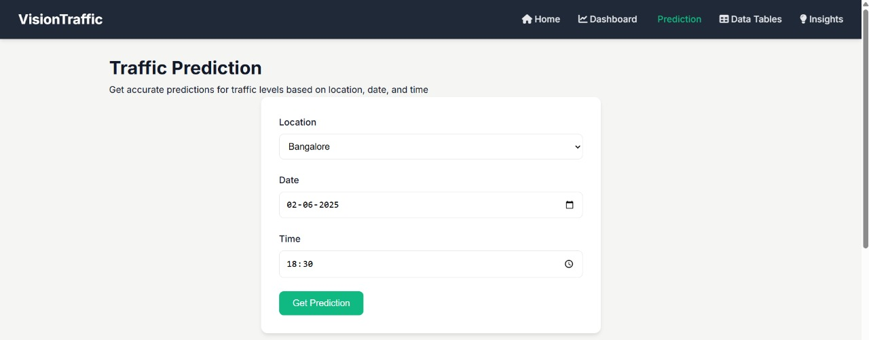

**Benefits:**

* **Enhanced Traffic Awareness:** The system offers both real-time and historical traffic insights, enabling commuters and logistics operators to make informed decisions regarding optimal travel routes and departure times.
* **Accessible, User-Friendly Interface**: A simplified web interface allows users to input location, date, and time parameters without requiring technical expertise. This design ensures broad usability across a range of user groups.
* **Data-Driven Decision Making**: By leveraging live traffic data from the TomTom API and conducting Exploratory Data Analysis (EDA), the system supports evidence-based planning and reduces reliance on assumptions.
* **Transparent, Rule-Based Prediction**: Instead of utilizing complex machine learning algorithms, the system employs a rule-based prediction model. This approach improves interpretability, simplifies maintenance, and ensures consistent results with fewer computational requirements.
* **Integrated Visual Dashboard**: The Power BI dashboard enhances the platform by offering interactive visualizations of traffic flow, speed, and congestion trends. These insights aid stakeholders in long-term traffic management and policy development.
* **Support for Efficient Resource Planning**: Transport authorities, fleet managers, and delivery services can use the system’s forecasts to optimize vehicle deployment, reduce idle times, and minimize fuel consumption.
* **Cost-Effective Implementation**: The project is designed around publicly accessible traffic data and open-source tools, demonstrating a practical and budget-conscious solution for traffic monitoring and prediction.

**Challenges and Considerations:**

* Incomplete or Noisy Data: Real-time traffic data from external APIs such as TomTom may occasionally be delayed, missing, or inconsistent, which can impact the reliability of predictions.
* Absence of Machine Learning Models: The system currently uses a rule-based logic framework. While it is straightforward and interpretable, it may fall short in identifying complex or non-linear traffic patterns that machine learning models are capable of capturing.
* Dependency on Exact Location Matching: Prediction accuracy relies on the availability of historical data for specific locations and time periods. In cases where data is limited, fallback strategies are used, which may reduce precision.
* User Input Dependency: The system requires manual input of location, date, and time. Incorrect formatting or invalid entries can lead to failed predictions or inaccurate outputs.
* Scalability Challenges: As traffic data accumulates over time, maintaining database performance and ensuring quick response times for queries and dashboard updates require optimization strategies, such as indexing and efficient data storage.
* Basic Web Interface: Although functional, the current web interface offers limited interactivity. Features such as dynamic maps, live overlays, or advanced visual analytics are not yet implemented, which may restrict user engagement.
* No Integration with Weather or Incident Data: External factors like weather conditions or traffic accidents, which significantly influence traffic flow, are not included in the current prediction model.
* Dependence on Third-Party API Services: The system relies on continuous access to the TomTom Traffic API. Any changes in pricing, rate limits, or service availability could affect the system’s sustainability.
* Data Privacy and Security Considerations: In a scaled deployment, proper measures would be required to safeguard user inputs and traffic logs to comply with data protection standards and ensure secure data handling

**Results:**

The traffic prediction system developed in this project effectively combines real-time data from the TomTom API with Python-based analysis to estimate traffic conditions—categorized as Light, Moderate, or Heavy—based on user-provided inputs such as location, date, and time of day. The rule-based prediction approach, built on defined thresholds for speed and delay, delivered consistent outcomes during testing. Furthermore, the integration with Power BI provided a clear and interactive visualization of historical traffic patterns, enhancing the system’s ability to support traffic monitoring and decision-making processes.

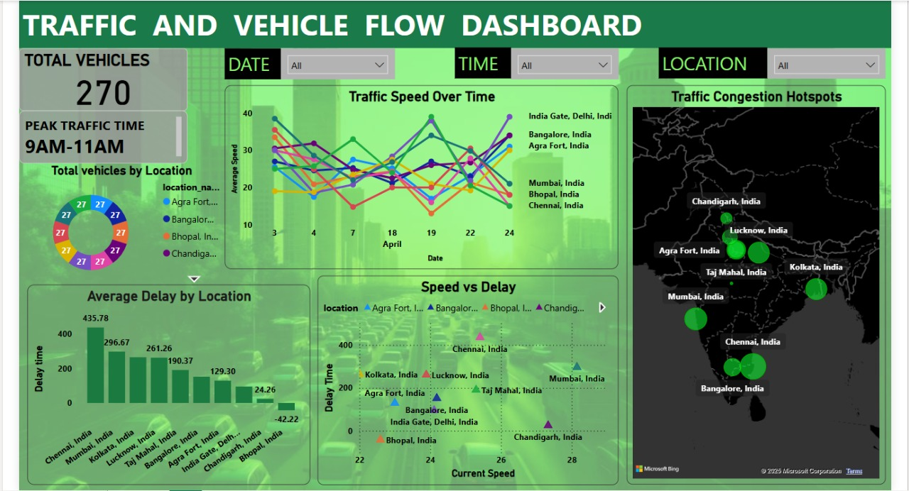

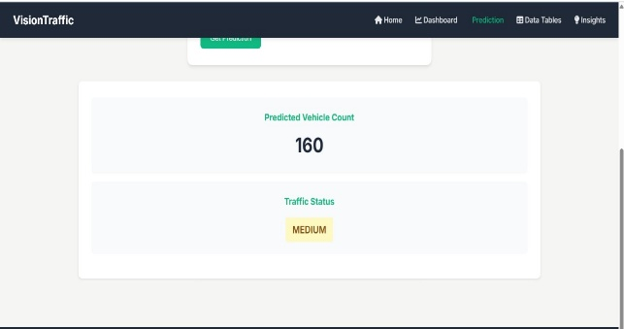

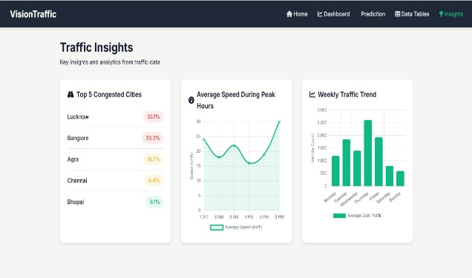

**Conclusion:**

This project presents a practical and interactive solution for traffic prediction by combining live data, rule-based logic, database storage, and visualization tools. It offers real-time insights into traffic congestion without requiring complex machine learning models. The system provides a strong foundation for building more intelligent transportation applications and demonstrates how data-driven methods can enhance travel planning and resource management in urban environments

**Future Scope:**

1. Machine Learning Integration

Future versions can implement ML algorithms like Decision Trees or Random Forests to enhance prediction accuracy using more complex features.

1. Live Location Tracking

Integration with GPS systems can enable real-time vehicle tracking and on-the-go predictions.

1. Weather and Incident Data

Adding external data like weather forecasts or road incidents will improve traffic condition accuracy.

1. Advanced Web Features

A more dynamic UI with map-based predictions, charts, and user history can be developed for better interactivity.

1. Mobile App Development

The system can be extended into a mobile application to provide easy access and real-time notifications.

1. Alert System

Implementing SMS or email alerts for heavy traffic warnings based on user preferences.

**Applications:**

* Urban Traffic Management: Municipal traffic control departments can utilize the system to monitor current congestion levels, enabling timely decisions for traffic redirection, signal timing adjustments, and road safety initiatives.
* Smart City Integration: The system aligns with smart city frameworks, contributing to infrastructure planning and intelligent transport management through the use of real-time data and analytical insights.
* Support for Daily Commuters: Individuals can access predicted traffic conditions through the web interface before starting their journeys, helping them choose efficient routes and avoid traffic delays.
* Logistics and Fleet Optimization: Companies involved in goods delivery and transportation can plan vehicle movements more effectively by factoring in expected traffic conditions, improving on-time performance and reducing operational costs.
* Public Transportation Planning: Transport authorities can analyze long-term traffic patterns to identify frequently congested areas and adjust bus or train schedules to ensure better service coverage and timing.
* Emergency Response Routing: Emergency services such as police, ambulances, and fire units can use real-time traffic data to identify the quickest routes, minimizing response times during critical situations.

**References:**

1. TomTom Developer API : <https://developer.tomtom.com>
2. Pandas Documentation: <https://pandas.pydata.org/docs>
3. MySQL Official Documentation: <https://dev.mysql.com/doc>
4. Power BI Official Site: <https://powerbi.microsoft.com>
5. Matplotlib & Seaborn (for EDA): <https://matplotlib.org/> <https://seaborn.pydata.org/>